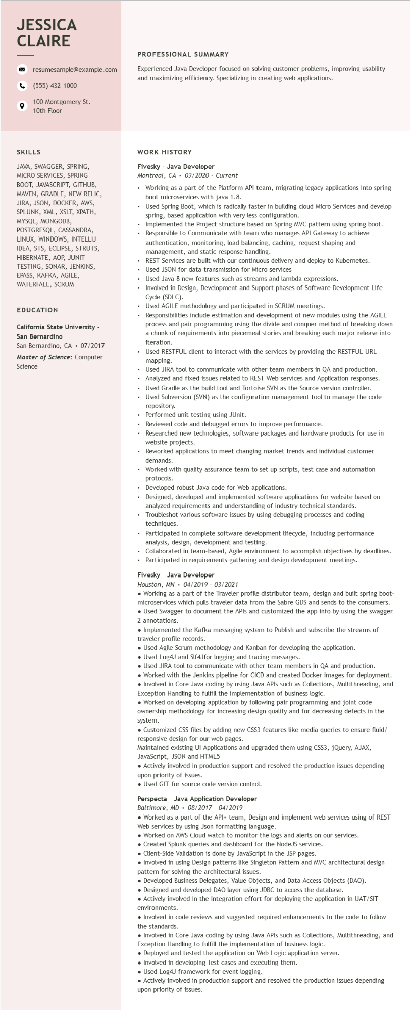
JESSICA CLAIRE
resumesample@example.com
(555) 432-1000
100 Montgomery St.
10th Floor
PROFESSIONAL SUMMARY
Experienced Java Developer focused on solving customer problems, improving usability and maximizing efficiency. Specializing in creating web applications.
SKILLS
JAVA, SWAGGER, SPRING, MICRO SERVICES, SPRING BOOT, JAVASCRIPT, GITHUB, MAVEN, GRADLE, NEW RELIC, JIRA, JSON, DOCKER, AWS, SPLUNK, XML, XSLT, XPATH, MYSQL, MONGODB, POSTGRESQL, CASSANDRA, LINUX, WINDOWS, INTELLIJ IDEA, STS, ECLIPSE, STRUTS, HIBERNATE, AOP, JUNIT TESTING, SONAR, JENKINS, EPASS, KAFKA, AGILE, WATERFALL, SCRUM
EDUCATION
California State University - San Bernardino
San Bernardino, CA ⚫ 07/2017
Master of Science: Computer Science
....
WORK HISTORY
Fivesky - Java Developer
Montreal, CA 03/2020 Current
Working as a part of the Platform API team, migrating legacy applications into spring boot microservices with java 1.8.
Used Spring Boot, which is radically faster in building cloud Micro Services and develop spring, based application with very less configuration.
Implemented the Project structure based on Spring MVC pattern using spring boot. Responsible to Communicate with team who manages API Gateway to achieve authentication, monitoring, load balancing, caching, request shaping and
management, and static response handling.
REST Services are built with our continuous delivery and deploy to Kubernetes. Used JSON for data transmission for Micro services
Used Java 8 new features such as streams and lambda expressions.
Involved in Design, Development and Support phases of Software Development Life Cycle (SDLC).
Used AGILE methodology and participated in SCRUM meetings.
Responsibilities include estimation and development of new modules using the AGILE process and pair programming using the divide and conquer method of breaking down a chunk of requirements into piecemeal stories and breaking each major release into iteration.
• Used RESTFUL client to interact with the services by providing the RESTFUL URL mapping.
Used JIRA tool to communicate with other team members in QA and production. Analyzed and fixed issues related to REST Web services and Application responses. • Used Gradle as the build tool and Tortoise SVN as the Source version controller. Used Subversion (SVN) as the configuration management tool to manage the code repository.
Performed unit testing using JUnit.
Reviewed code and debugged errors to improve performance.
Researched new technologies, software packages and hardware products for use in website projects.
Reworked applications to meet changing market trends and individual customer demands.
Worked with quality assurance team to set up scripts, test case and automation protocols.
• Developed robust Java code for Web applications.
.
Designed, developed and implemented software applications for website based on
analyzed requirements and understanding of industry technical standards. Troubleshot various software issues by using debugging processes and coding
techniques.
Participated in complete software development lifecycle, including performance analysis, design, development and testing.
•
Collaborated in team-based, Agile environment to accomplish objectives by deadlines.
• Participated in requirements gathering and design development meetings.
Fivesky - Java Developer
Houston, MN
04/2019-03/2021
• Working as a part of the Traveler profile distributor team, design and built spring boot- microservices which pulls traveler data from the Sabre GDS and sends to the consumers.
• Used Swagger to document the APIs and customized the app info by using the swagger 2 annotations.
• Implemented the Kafka messaging system to Publish and subscribe the streams of traveler profile records.
• Used Agile Scrum methodology and Kanban for developing the application.
• Used Log4J and Slf4Jfor logging and tracing messages.
• Used JIRA tool to communicate with other team members in QA and production.
• Worked with the Jenkins pipeline for CICD and created Docker images for deployment.
• Involved in Core Java coding by using Java APIs such as Collections, Multithreading, and Exception Handling to fulfill the implementation of business logic.
• Worked on developing application by following pair programming and joint code ownership methodology for increasing design quality and for decreasing defects in the system.
• Customized CSS files by adding new CSS3 features like media queries to ensure fluid/ responsive design for our web pages.
Maintained existing UI Applications and upgraded them using CSS3, jQuery, AJAX, JavaScript, JSON and HTML5
• Actively involved in production support and resolved the production issues depending upon priority of issues.
• Used GIT for source code version control.
Perspecta Java Application Developer
Baltimore, MD 08/2017 04/2019
• Worked as a part of the API+ team, Design and implement web services using of REST
Web services by using Json formatting language.
• Worked on AWS Cloud watch to monitor the logs and alerts on our services.
• Created Splunk queries and dashboard for the NodeJS services.
• Client-Side Validation is done by JavaScript in the JSP pages.
• Involved in using Design patterns like Singleton Pattern and MVC architectural design
pattern for solving the architectural issues.
• Developed Business Delegates, Value Objects, and Data Access Objects (DAO).
• Designed and developed DAO layer using JDBC to access the database.
• Actively involved in the integration effort for deploying the application in UAT/SIT environments.
• Involved in code reviews and suggested required enhancements to the code to follow the standards.
• Involved in Core Java coding by using Java APIs such as Collections, Multithreading, and Exception Handling to fulfill the implementation of business logic.
• Deployed and tested the application on Web Logic application server.
• Involved in developing Test cases and executing them.
• Used Log4J framework for event logging.
• Actively involved in production support and resolved the production issues depending upon priority of issues.

